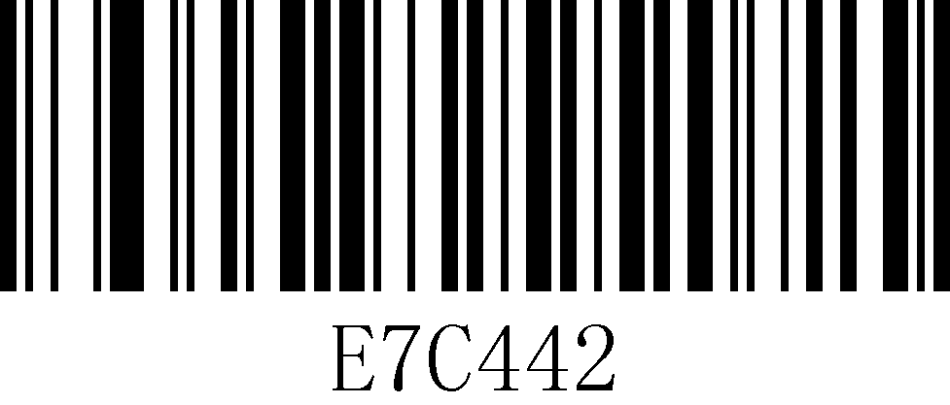
Factory Default Manual Scanning
Interfaces

USB Keyboard

USB COM
RS232

Add CR

Cancel CR

Add LF

Cancel LF

*Add CR&LF

Cancel CR&LF

Keyboard Languages

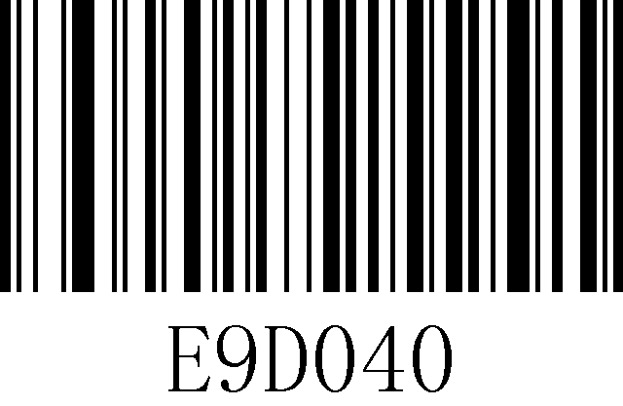
Belgium

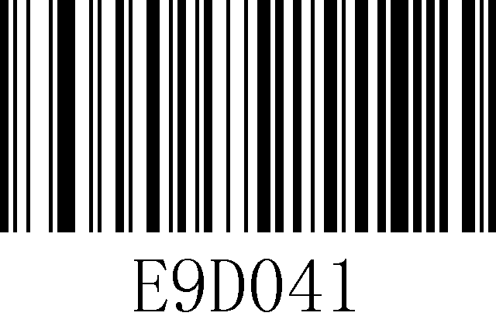
UK

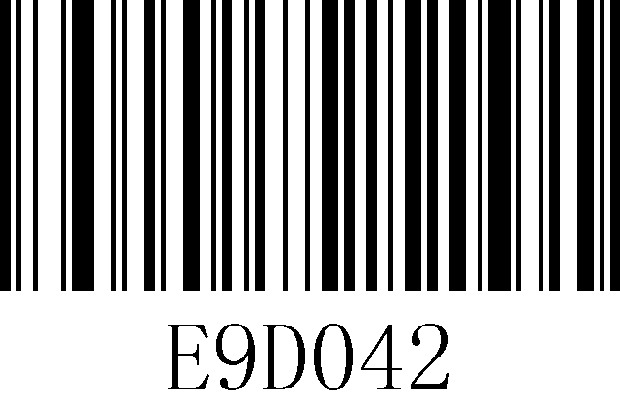
France

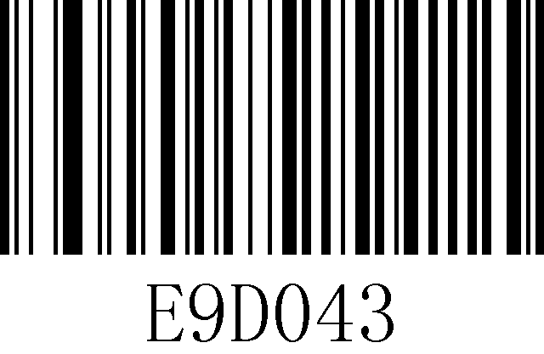
German

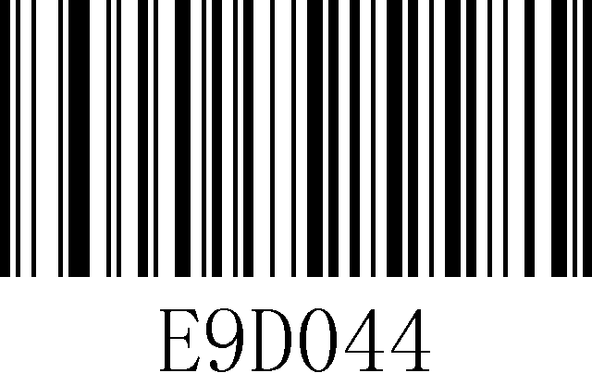
Italy
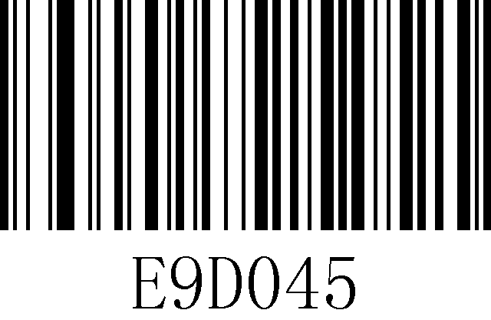
Spain

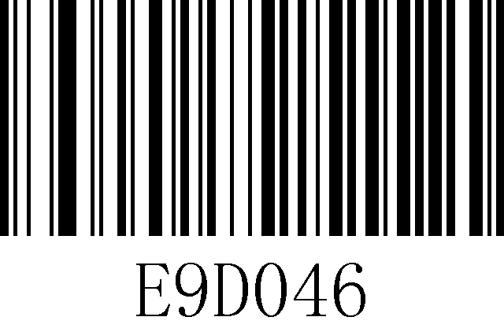
USA

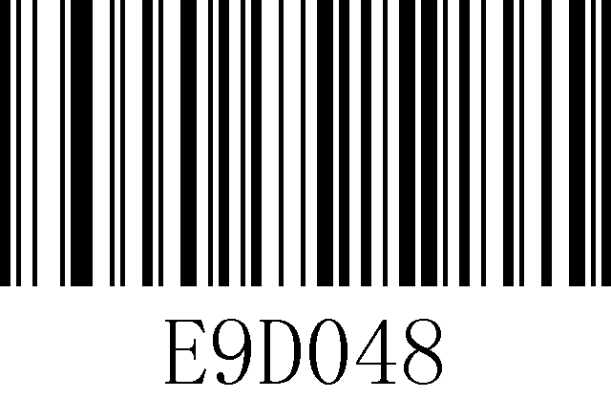
Singapore

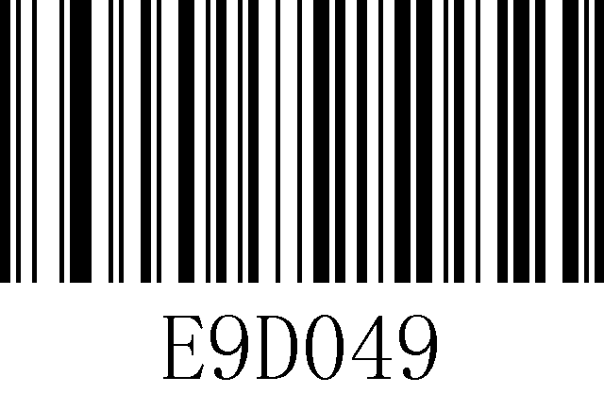
Salvador

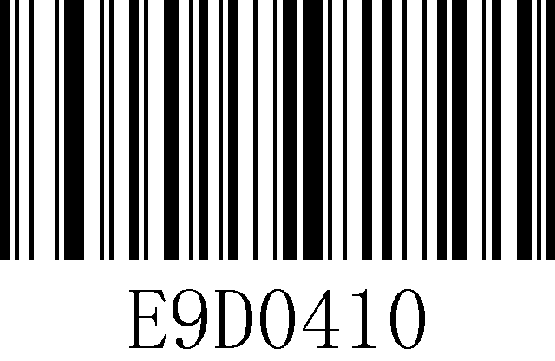
Japan

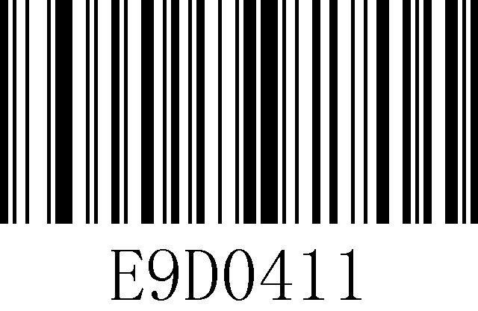
Slerra Leone

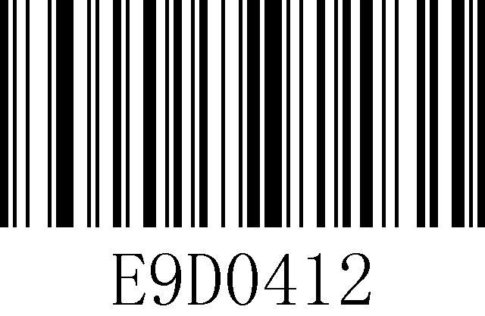
Turkey

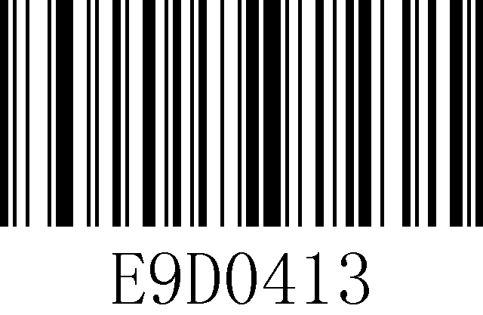
Russia

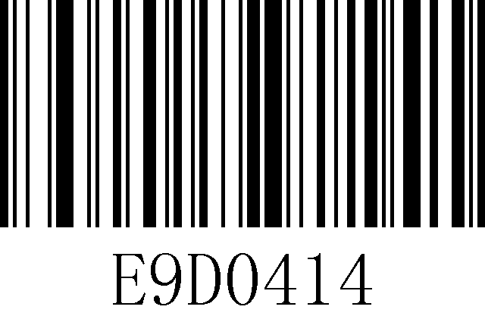
Hungary

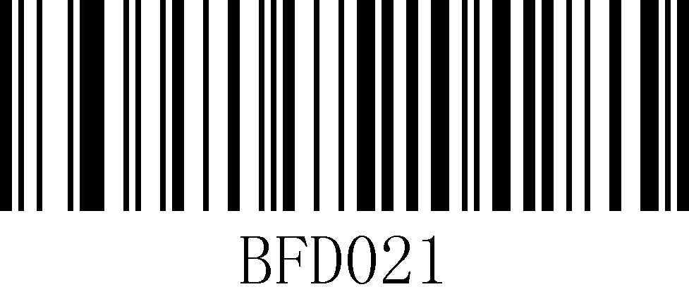
All Lower Case

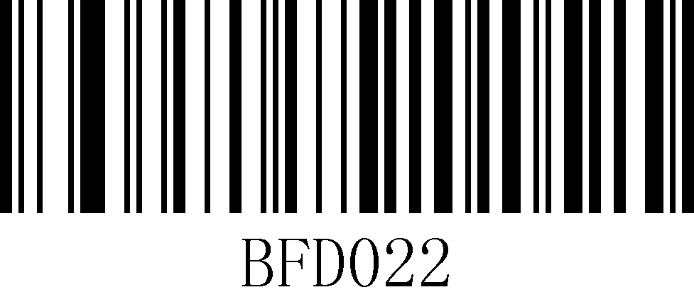
All Capital

1. UPC/EAN
*Enable

Disable

2. Codabar
*Enable

Disable

3．Code39

*Enable

Disable

4. Full ASCII Code39

Enable

Disable

5．Interleaved 2 of 5

*Enable

Disable

6. Code93

Enable

*Disable

7.Straight 2 of 5 Industrial

Enable

*Disable

8.Code 11

Enable

*Disable

9. Code 128

*Enable

Disable

10. UPC-A
*Enable

Disable

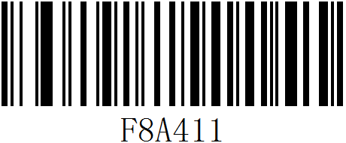
UPC-E Convert to EAN 13

11. EAN-13
*Enable
Disable

12. EAN-8

*Enable

Disable

13. MSI

Enable

*Disable

14. GS1 DataBar Omnidirectional

Enable

*Disable

15. GS1 DataBar Limited

Enable

*Disable

16. GS1 DataBar Expanded

Enable

*Disable

17. Trioptic Code

Enable

*Disable

18. Codablock A

Enable

*Disable

19. Codablock F

Enable

*Disable

20. PDF417
*Enable

Disable

21. MicroPDF417

Enable

*Disable

22. QR Code

*Enable

Disable

23. Mico QR Code
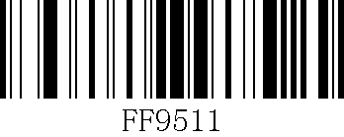
Enable

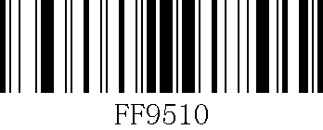
*Disable

24. Data Matrix Code

Enable

*Disable

25. Aztec Code

Enable

*Disable

26. Matrix 2 of 5

Enable

*Disable

27. Code 32

Enable

*Disable

Add prefix/suffix (add at most 10 characters respectively)
Add prefix instruction：
For Example: Add one byte prefix, byte character is "®", the corresponding ASCII decimal number is 174
- Use scanner to read “Enter/Exit Configuration Mode”
- Use scanner to read “Prefix 1 Byte”
- Use scanner to read bytecode value “1”，“7”，“4”in order
- Use scanner to read “Enter/Exit Configuration Mode”
Add suffix instruction：
For Example: Add one byte prefix, byte character is "$", the corresponding ASCII decimal number is 036
1, Use scanner to read “Enter/Exit Configuration Mode”
2, Use scanner to read “Suffix 1 Byte”
3, Use scanner to read bytecode value “0”，“3”，“6”in order
4, Use scanner to read “Enter/Exit Configuration Mode”
Add multi-bytes prefix instruction：
1, Use scanner to read “Enter/Exit Configuration Mode”
2, Use scanner to read “Prefix 1 Byte”
3, Use scanner to read bytecode value of the first byte in order
4, Use scanner to read “Prefix 2 Bytes”
5, Use scanner to read bytecode value of the second byte in order
6, Repeat steps 4&5 for more prefix byte
7, Use scanner to read “Enter/Exit Configuration Mode”
Add multi-bytes suffix instruction is the same with prefix

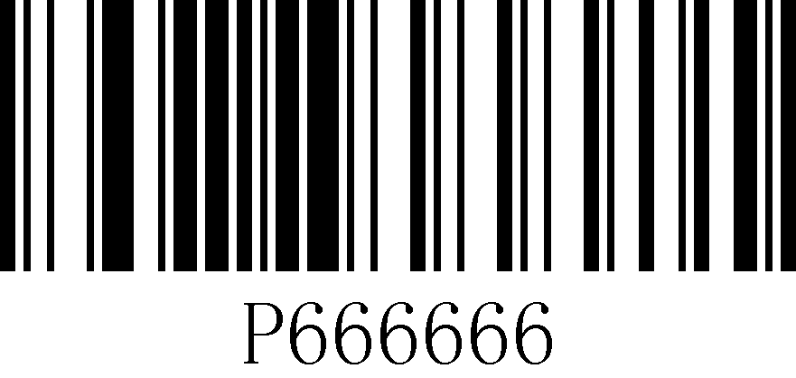
Enter/Exit Configuration Mode

Prefix 1 byte

Prefix 2 bytes

Prefix 3 bytes

Prefix 4 bytes

Prefix 5 bytes
Prefix 6 bytes

Prefix 7 bytes

Prefix 8 bytes

Prefix 9 bytes

Prefix 10 bytes

Clear All Prefix

Suffix 1 byte

Suffix 2 bytes

Suffix 3 bytes

Suffix 4 bytes

Suffix 5 bytes

Suffix 6 bytes

Suffix 7 bytes

Suffix 8 bytes

Suffix 9 bytes

Suffix 10 bytes

Clear All Suffix

Bytecode value (decimal)

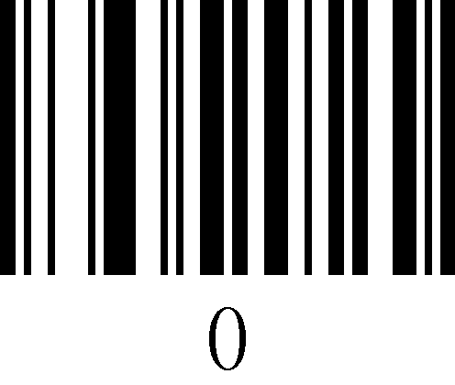

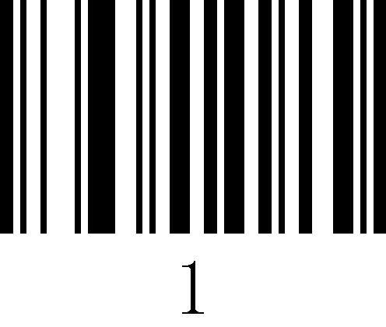

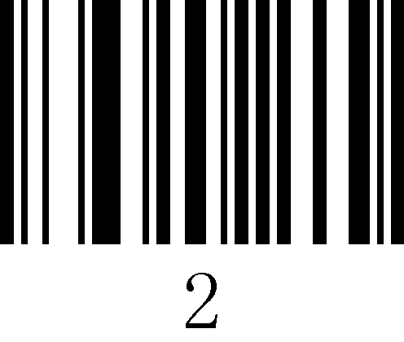

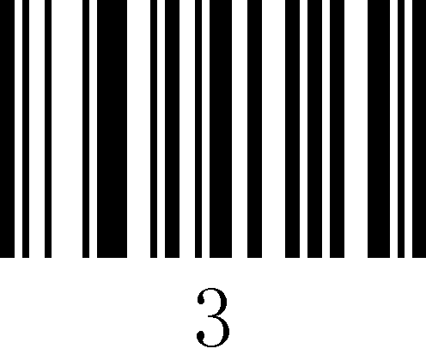

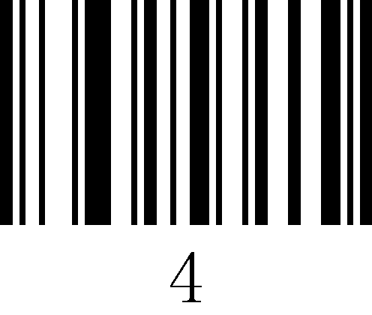

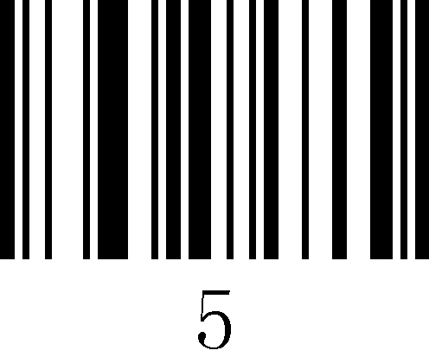

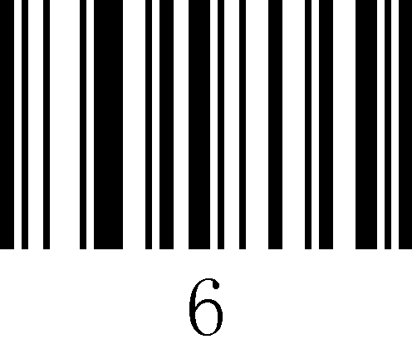

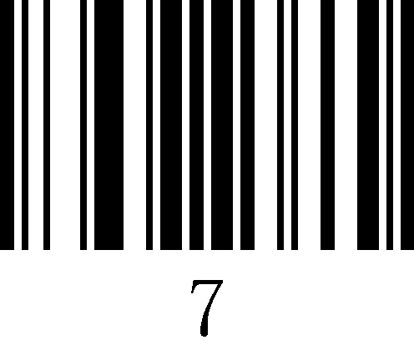

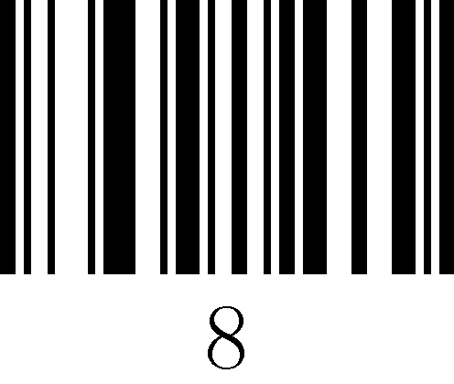

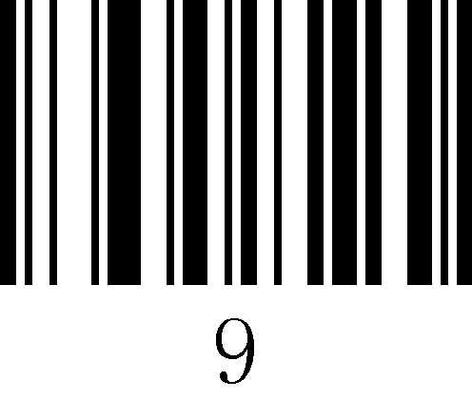

ASCII Table
Decimal number | Character | Decimal number | Character | Decimal number | Character | Decimal Number | Character
000 | NUL | 032 | SP | 064 | @ | 096 | ‘
001 | SOH | 033 | ! | 065 | A | 097 | a
002 | STX | 034 | " | 066 | B | 098 | b
003 | ETX | 035 | # | 067 | C | 099 | c
004 | EOT | 036 | $ | 068 | D | 100 | d
005 | ENQ | 037 | % | 069 | E | 101 | e
006 | ACK | 038 | & | 070 | F | 102 | f
007 | BEL | 039 | ` | 071 | G | 103 | g
008 | BS | 040 | ( | 072 | H | 104 | h
009 | HT | 041 | ) | 073 | I | 105 | i
010 | LF | 042 | * | 074 | J | 106 | j
011 | VT | 043 | + | 075 | K | 107 | k
012 | FF | 044 | , | 076 | L | 108 | l
013 | CR | 045 | － | 077 | M | 109 | m
014 | SOH | 046 | . | 078 | N | 110 | n
015 | SI | 047 | / | 079 | O | 111 | o
016 | DLE | 048 | 0 | 080 | P | 112 | p
017 | DC1 | 049 | 1 | 081 | Q | 113 | q
018 | DC2 | 050 | 2 | 082 | R | 114 | r
019 | DC3 | 051 | 3 | 083 | S | 115 | s
020 | DC4 | 052 | 4 | 084 | T | 116 | t
021 | NAK | 053 | 5 | 085 | U | 117 | u
022 | SYN | 054 | 6 | 086 | V | 118 | v
023 | ETB | 055 | 7 | 087 | W | 119 | w
024 | CAN | 056 | 8 | 088 | X | 120 | x
025 | EM | 057 | 9 | 089 | Y | 121 | y
026 | SUB | 058 | : | 090 | Z | 122 | z
027 | ESC | 059 | ; | 091 | [ | 123 | {
028 | FS | 060 | < | 092 | \ | 124 | |
029 | GS | 061 | = | 093 | ] | 125 | }
030 | RS | 062 | > | 094 | ^ | 126 | ~
031 | US | 063 | ? | 095 | _ | 127 | DEL

ASCII extended character (CP-1252)
Decimal number | Character | Decimal number | Character | Decimal number | Character | Decimal number | Character
128 | € | 160 |  | 192 | À | 224 | à
129 |  | 161 | ¡ | 193 | Á | 225 | á
130 | ‚ | 162 | ¢ | 194 | Â | 226 | â
131 | ƒ | 163 | £ | 195 | Ã | 227 | ã
132 | „ | 164 | ¤ | 196 | Ä | 228 | ä
133 | … | 165 | ¥ | 197 | Å | 229 | å
134 | † | 166 | ¦ | 198 | Æ | 230 | æ
135 | ‡ | 167 | § | 199 | Ç | 231 | ç
136 | ˆ | 168 | ¨ | 200 | È | 232 | è
137 | ‰ | 169 | © | 201 | É | 233 | é
138 | Š | 170 | ª | 202 | Ê | 234 | ê
139 | ‹ | 171 | « | 203 | Ë | 235 | ë
140 | Œ | 172 | ¬ | 204 | Ì | 236 | ì
141 |  | 173 |  | 205 | Í | 237 | í
142 | Ž | 174 | ® | 206 | Î | 238 | î
143 |  | 175 | ¯ | 207 | Ï | 239 | ï
144 |  | 176 | ° | 208 | Ð | 240 | ð
145 | ‘ | 177 | ± | 209 | Ñ | 241 | ñ
146 | ’ | 178 | ² | 210 | Ò | 242 | ò
147 | “ | 179 | ³ | 211 | Ó | 243 | ó
148 | ” | 180 | ´ | 212 | Ô | 244 | ô
149 | • | 181 | µ | 213 | Õ | 245 | õ
150 | – | 182 | ¶ | 214 | Ö | 246 | ö
151 | — | 183 | · | 215 | × | 247 | ÷
152 | ˜ | 184 | ¸ | 216 | Ø | 248 | ø
153 | ™ | 185 | ¹ | 217 | Ù | 249 | ù
154 | š | 186 | º | 218 | Ú | 250 | ú
155 | › | 187 | » | 219 | Û | 251 | û
156 | œ | 188 | ¼ | 220 | Ü | 252 | ü
157 |  | 189 | ½ | 221 | Ý | 253 | ý
158 | ž | 190 | ¾ | 222 | Þ | 254 | þ
159 | Ÿ | 191 | ¿ | 223 | ß | 255 | ÿ

