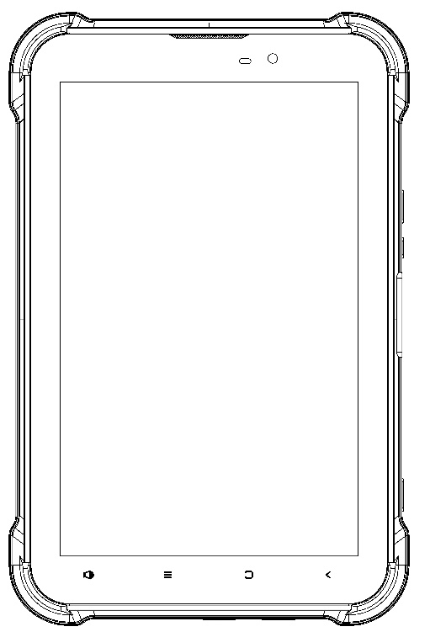

**Thanks for you purchasing this device.**

**Please carefully read user manual before usage.**

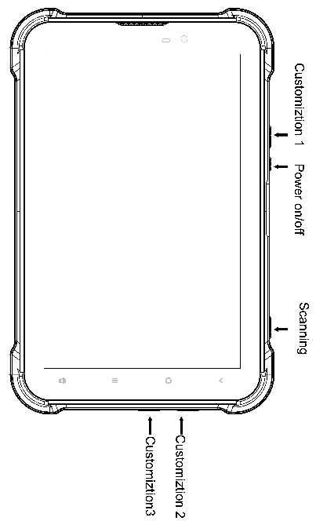

## keybuttons instruction

**1.Power：**Long time to push the Power button to turn-on/ off device.

In any interface, press power button one second into lock and unlock interface. Press 10seonds power button will be reset smart phone

**2.Volume controls：**

When you’re on the phone or listening to songs, movies, or other media, the buttons on the side of

Tablet adjust the audio volume. Otherwise, the buttons control the volume for the ringer, alerts,

and other sound effects.

**Vibration/Silent switch**

Vibration or Silent mode. It could be set by Touch application icon->setting->Device->Sound & notification

**3.Barcode reader button:**

Pushing Barcode reader button 3seconds the barcode reader function will be turned on, Shortly press the scanner key to enter the scanning mode. (noted: before scanning you should open a dialog box and put it in the typing status， the reader information will show in the dialog box. Please reference the pictures as follows)

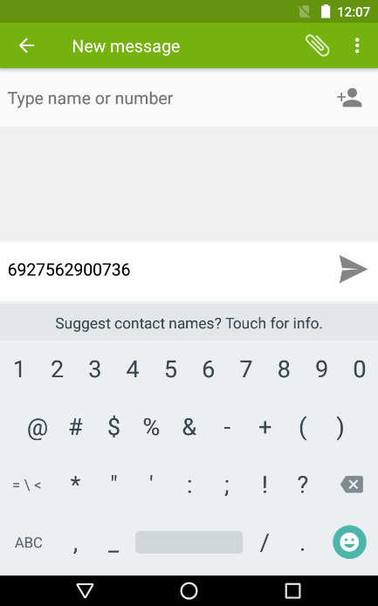

## 4. Fingerprint (Optional).

## There is a demo “SZOEMHost_And” for you testing the fingerprint function. Please contact us to get the SDK for you futher development this function.

## 5. Install SIM card, TF card

Please turn off device before you install the SIM cards or TF card

**Please turn off the device before you take out the SIM cards or TF card**

**6. Status Icon**

|  |  |  |  |
| --- | --- | --- | --- |
|  | E: GSM  3G: WCDMA  4G: 4G LTE |  | Notification |
|  | Call forwarding |  | Play music |
|  | Miss calling |  | Connected WLAN |
|  | New SMS or MMS |  | Calling out |
|  | Alarm Clock |  | Airplane mode |
|  | Vibration mode |  | Silent |
|  | Bluetooth |  | Battery capacity |
|  | Connect to PC |  | Barcode reader on |
|  | Connected earphone |  | Charging |

**7.Notification Center**

Notification Center collects your notifications in one place, so you can review them whenever you’re ready. Review all your alerts, or just the ones you missed. All alrts including new messages, Calendar activities and ongoing activities, such as incoming calls or current call status.

Open Notification Center: Swipe down from the top edge of the screen.

Turn off Notification Center: Swipe up from the down of the Notification bar.

Remark: sleep or standby mode, please wake up the tablet and swipe donw from the top edge of the screen into quickly operate WLAN, bluetooth, auto-rotate,airplane, NFC on/off

**8. Applications icon**

Touch  get all apllications on the Tablet. Touch return icon back to homepage.

**9.Recently application**

Long time to touch homepage into recently used applications, for example photo, wallpapers etc what you used. Swipe or click from left to right this icon to remove traces of the most recently running application

**10. Expand the homepage**

Main interface to go beyond the screen width for more spaces in which new shortcuts, widgets and more other items can be added. In addition, users can horizontally swipe their fingers at the homepage screen to move to the left or right of the expanded the homepage interface.

1. in standby mode, long pressing the blank part of the display to enter settings of homepage interface.

2. choosing widgets, add whichever one you want to show in the homepage, it will automatically in the blank space of homepage.

3.in homepage interface, tab and pin any app icon, to drag it to the blank space of homepage.

**11. Move homepage interface icons:**

1. Tabbing and pin the icon till the icon become bigger.

2. Stay still of your finger and drag the icon to the place where you want it to be on the homepage.

**12. Remove homepage interface icons.**

1. Tabbing and pin the icon till the icon become bigger.

2. Stay still of your finger, drag the icon till it become red, then leave your finger.

3. When all the icons and widgets in the homepage been deleted, this homepage will be deleted automatically.

# 13.Management of device

Please go to settings menu to set your device.

**14. Wireless and network**

**Management of SIM：**

Setting SIM1 or SIM 2 card turn on/off which in the menu settings🡪SIM cards. It will show airplane mode icon on the status bar after you turn off the SIM card.

**15.Setting cellular date turn on/off.**

Settings-》SIM cards-》preferred sim for

**16. SIM cards application**

Please find the SIM toolkit menu in the main system to understand more information

**17. Wi-Fi**

Settings🡪Wi-Fi-》turn on-> choose the Wi-Fi name and input the password to connected Wi-Fi

**18. Bluetooth**

Settings🡺Bluetooth🡺turn on 🡺choose the one of available devices to pair.

**19. More：**

Airplane mode: there is no any service after you turn on the function。

VPN: VPN network.

Network sharing & portable hotspots:Allow the equipment of wireless network without through wireless router connected to each other（Wi-Fi hotspots); Share your mobile connection via USB（USB sharing network）; Choose to share or not share computer internet connection.

Mobile network:Check data usage，open or close 4G/3G service，change network mode,access point name，select a network provider in operators.

**20. Device**

**Display:** Setting device display brightness, wallpaper, Auto Rotate Screen, sleeping mode, body size and other display function.

**21.Cue tone & notice:** Set voice volume and ring setup.

**22. Storage: Check** SD card and relevant display information of mobile phone, can download or format SD card.

**23. Battery:** Show the usage of battery capacity.

**24. Application:** Manage and delete installed applications. Check and control storage usage of running service and apps.

**25. User**: Set main and visitor pattern.

**26. Touch payment**: Support touch payment function.

**27. Gesture:** Support gloves functions，double click to wake up under standby condition，support gesture to open camera and torch function.Under the condition of opening gesture, it will automatically switch to normal touch mode if there is no any operation within 15 seconds, please switch back on gloves function if needed.

**28.Person**

**Location information:** Set relevant functions about my location.

**29.Security**

Screen lock: Use picture, PIN or password to lock screen.

**30. Device manager:** Manage relevant devices.

**31. Unknown sources:** Setting if allowed to download application from non-electric market.

When your setting is allowed, your phone and personal data will be easy to be attacked by applications of unknown sources, you will be responsible for the loss because of these applications.

Trusted Credentials: Allows the application to access security credentials and other credential.

Storage and install from mobile phone:After clicked，you will Install storage encryption certificates from mobile.

Clear credentials: Clear all the credential store content.

**32. Account**

**Add account:** You can add accounts, add the required account; Through the full synchronization, set all current account into sync. Conventional synchronous Settings to set the background data, automatic synchronization.

**33. Back up and reset:** Through the factory default, remove all the data on the phone. Remove data including: account, system and application data and Settings, download should be: select the appropriate language, setting the keyboard and select the default input method.

The application does not delete data including the current system software, SD Calvin parts, such as music or photos.

**34. System**

**Date and time:** setting Automatic date & time, Automatic time zone, Use 24-hour format.

**Accessibility**: Adjust miscellaneous function

**Print:** Can be printed after installation service

**About Phone:** Can be checked Status, Legal information, Model Number, Processor information, android version, Energy version, Kernel version, Build Number

**35.USB connection**

**USB charging**

There is default charging function when you connect the device with your computer.

**How to copy your file or pictures from device to your computer?**

Please connect the device with your computer by type-C cable then slip the touch screen from top to low -side then you will see the information as follow pictures.

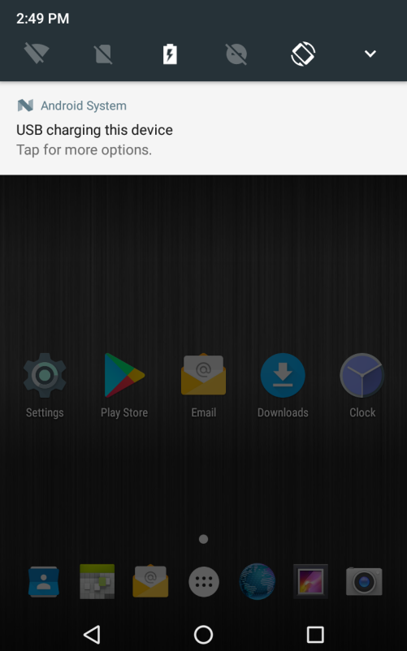

Please click the “USB for file transfer” you will get the follow picture:

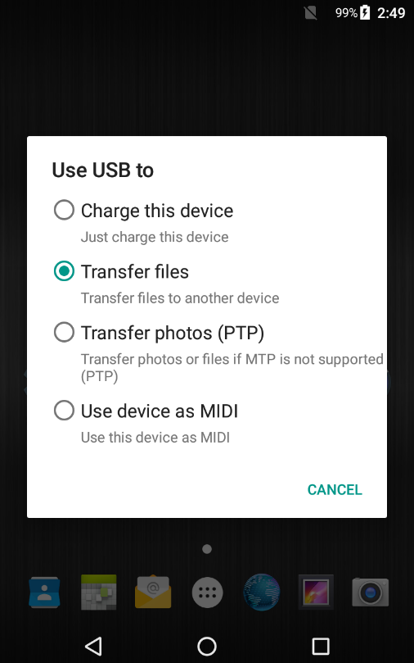

**Choosing transfer files then you will find the file or pictures in your computer.**

**36. Maintenance and Layup**

**User’s Manual for Battery**

The rechargeable battery may serve as power source of the mobile phone. Please charge the battery when it becomes low in electricity. It is recommended to use up the battery capacity before charging for the sake of longer battery life.

Please do not attach the battery charger to any power supply if the charger is not in service. Never attach the charger to the battery for over one week as excessive charging will shorten the battery life.

Temperature will challenge chargeable limit of the battery, so the battery may need to be cooled down or warmed up prior to charging. Charging will fail if the battery temperature is above 55oC or below -20oC.

Please only use the battery for its originally-designed purpose to avoid short circuit. Short circuit will occur if the cathode and anode of the battery are connected via a conductor.

Never use the battery if it has become damaged.

The battery life will become shortened if the battery is placed in any extremely-hot or extremely-cold environment. The mobile phone may not function properly if the battery is exposed to any extremely-hot or extremely-cold environment even if the battery is fully charged.

Do not put the battery in fire. Do not throw away any used batteries. Used batteries shall be sent to battery recycling services and disposed in accordance with local regulations.

**37. Mobile Phone Layup**

The following recommendations will be conducive to layup of your mobile phone:

Please place the mobile phone and all accessories at any place away from children.

Please keep the phone dry as liquid will corrode metallic circuit.

Please keep the phone away from high temperature as high temperature will shorten life of electronics, melt plastics and damage the battery.

Do not attempt to open the phone case or disassemble the phone. Non-professional dis-assembly will potentially damage the phone.

Do not use any detergent containing strong acid or base to clean the phone.

Always use original accessories, violation of which will void its warranty.

**38. Safety Information**

Always observe safety regulations for protecting users and environment when using the mobile phone.

**39. Traffic Safety**

Unless in emergency, please do not use the mobile phone while driving if no hands-free devices for safety and free movement are attached. Make sure that you are fully concentrated to driving. Please pull up your car to a safe place before you use the phone. Related regulations must be observed.

Some electronics may be affected by radio waves from transmitted by your mobile phone if no sufficient protection is made available.

It is recommended to use the mobile phone only in vehicles with external antenna.

Always have qualified technicians install the mobile phone onto your vehicle.

**40. Flight Safety**

Please switch off your mobile phone before boarding as mobile phones will challenge operation of aircraft and entire cellular network. It is illegal to use mobile phones on the plane and violation of these safety regulations will be accused or result in network denial-of-service.

**41. Environmental Safety**

Keep in mind to observe existing particular rules and policies at any places. Always remember to switch off your mobile phone where use of mobile phone is prohibited or may result in interference or danger.

Use of any wireless transmitting equipment, including cellular phone, might interfere with medical device not properly protected. Please ask doctor or medical device manufacturer for advice should you have any questions in this respect.

Your mobile phone might interfere with hearing aids, pacemaker and other medical electronics. Please follow suggestions from doctor or the manufacturer.

Users are recommended to switch off their mobile phones at any places where explosion may occur, e.g. gas station and chemical plants. Observe related restrictions on use of wireless devices.

**42.System Update Security**

The mobile phone is typically subject to authorized operating system update.

Any unauthorized operating system update might result in failure of updated operating system to comply with security requirements for mobile intelligent terminals, with system information security loophole.